First Screen showing two options for season and plants category:

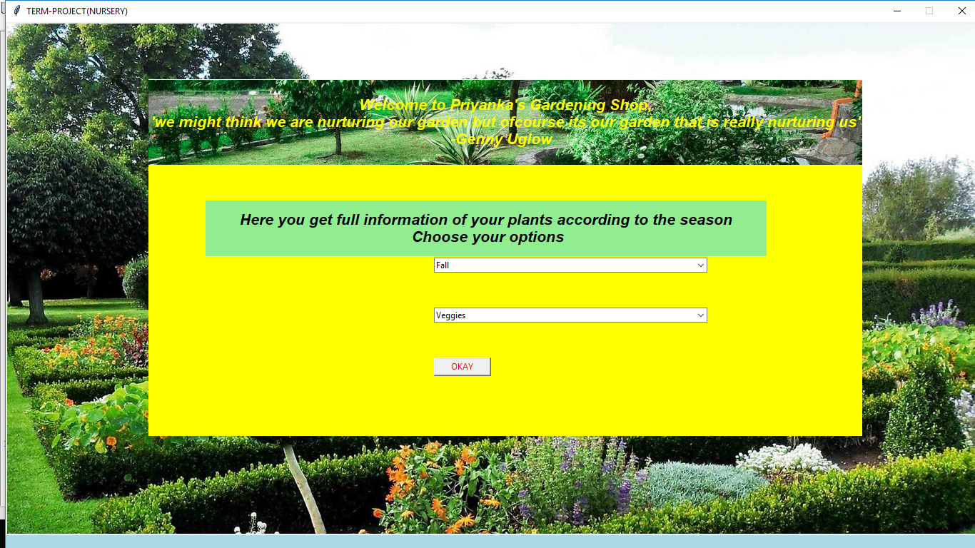

After click okay button

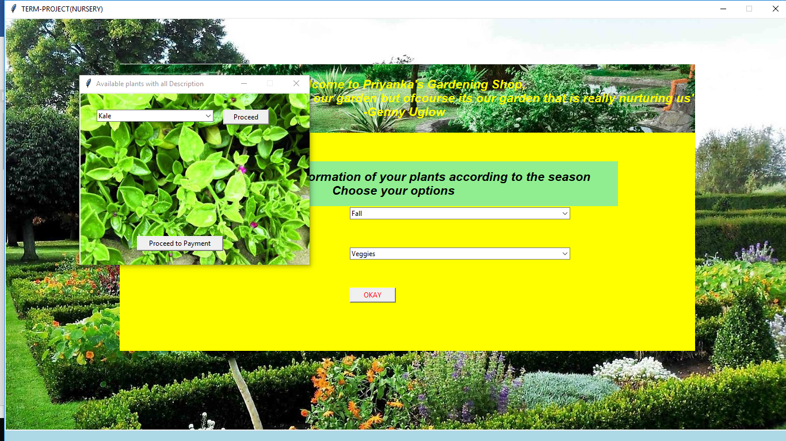

Combo box shows all information of vegetables from fall season

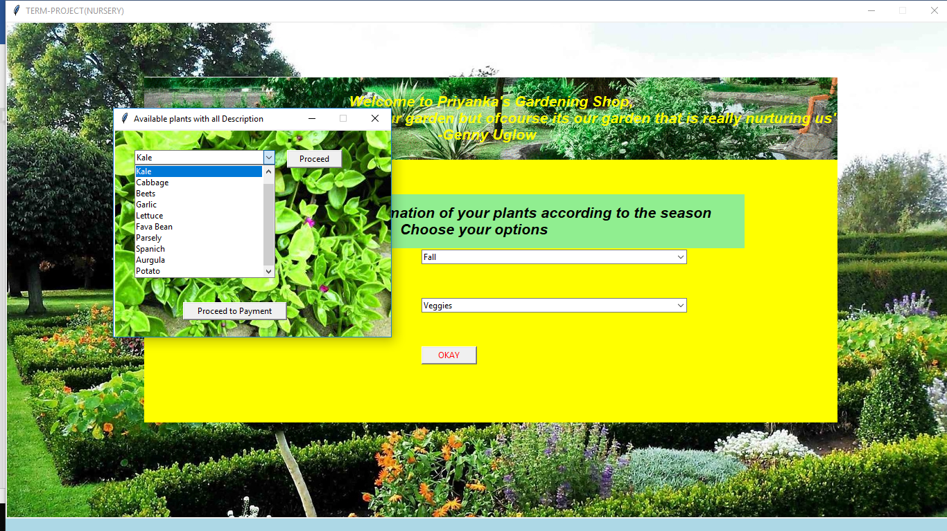

After click proceed, details of selected item is shown

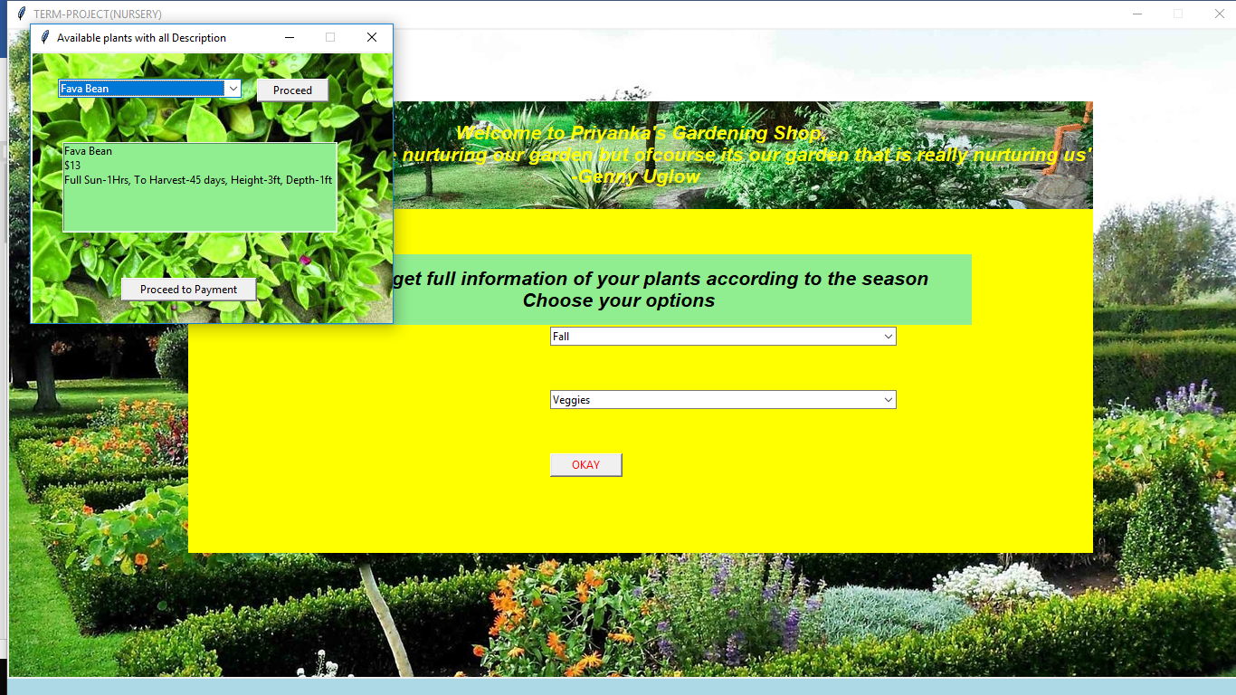

After click “Procced to payment” message box is invoked

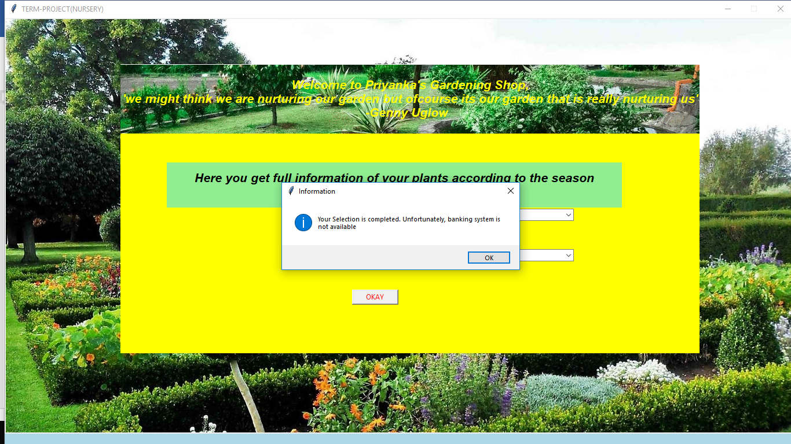

DataBase:

